Abu Hossain Mohammad Abed Hasan Tias
ID 21301295
CSE470 SEC- 13

1.NO.Q.ANS
=The required features are that there is 1 instance of twitter channel. And the next feature is that when the channel is updated the users or subscribers will also be updated of the change. For the first feature, a singleton design pattern needs to be used to ensure only 1 instance of twitter channel. And for the next feature observer design pattern needs to be used to let the observer know of any change to the subject. A singleton design pattern ensures the class has 1 instance and provides a global point to access it. An observer design pattern intends a one-to-many dependency between objects so that when 1 object changes state, all its dependents are notified and updated automatically.

Code
class Subscriber:
def __init__(self, name):
self.name = name

def update(self, title):
print(f"{self.name} has been notified of a new video: {title}")

class Twitter:
_instance = None
_subscribers = []

def __new__(cls):
if cls._instance is None:
cls._instance = super(Twitter, cls).__new__(cls)
cls.channel_name = "Twitter"
cls.videos = []
return cls._instance

def subscribe(self, subscriber):
self._subscribers.append(subscriber)
print(f"{subscriber.name} has subscribed to {self.channel_name} channel.")

def upload(self, title):
self.videos.append(title)
for subscriber in self._subscribers:
subscriber.update(title)

if __name__ == "__main__":
channel = Twitter()
user1 = Subscriber("tias")
user2 = Subscriber("hasan")
channel.subscribe(user1)
channel.subscribe(user2)
channel.upload("subscribe please")

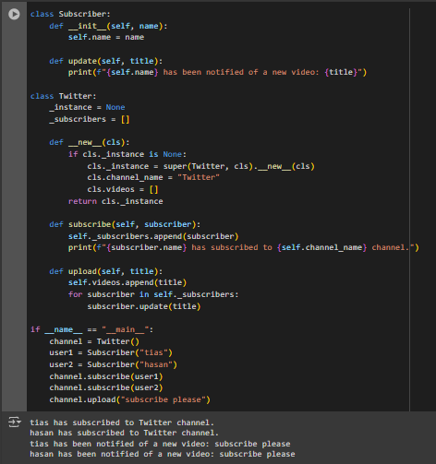

2.NO.Q.ANS
= Here the only feature needed is that the subscribers get notified of any update to the channel that they are subscribed to. Hence, observer pattern is to be implemented.

Code
class Subscriber:
def __init__(self, name):
self.name = name
self.subscribed = []

def update(self, title):
print(f"{self.name} has been notified of a new video: {title}")

def subscribe(self, channel):
self.subscribed.append(channel)
print(f"{self.name} has subscribed to {channel.name} channel.")

def unsubscribe(self, channel):
self.subscribed.remove(channel)
print(f"{self.name} has unsubscribed from {channel.name} channel.")

def update(self, channel, title):
print(f"{self.name} has been notified of a new video on {channel}: {title}")

class Channel:
def __init__(self, name):
self.name = name
self.subscribers = []
self.videos = []

def subscribe(self, user):
self.subscribers.append(user)
user.subscribe(self)

def unsubscribe(self, user):
self.subscribers.remove(user)
user.unsubscribe(self)

def upload(self, title):
self.videos.append(title)
print(f"New video uploaded on {self.name} channel: {title}")
for user in self.subscribers:
user.update(self.name, title)

if __name__ == "__main__":
twitter = Channel("Twitter")
LTT = Channel("Linus-Tech-Tips")
user1 = Subscriber("me")
user2 = Subscriber("myself")
user3 = Subscriber("and I")
twitter.subscribe(user1)
twitter.subscribe(user2)
LTT.subscribe(user1)
LTT.subscribe(user3)
twitter.upload("we are banning indians")
LTT.upload("apology video")
twitter.unsubscribe(user1)
twitter.upload("we are banning rainbow")
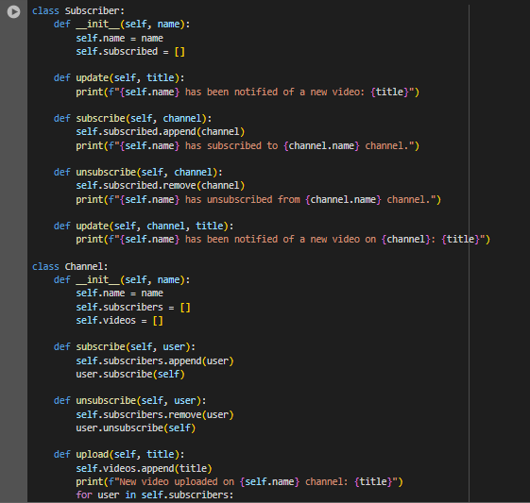
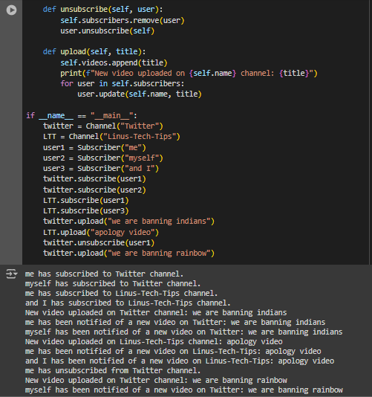
3.NO.Q.ANS
=As there are more than 1 instance of, we chat active at a time and there is no need for the users to be notified of any subject. The users are just using different features; hence, adapter design pattern will be used to ensure that all the features from different sites will work properly in our app according to our client’s request.

Code
class Messenger:
def sendMessage(self):
print("Sending message using Messenger.")

class Facebook:
def useNewsFeed(self):
print("Using Facebook's news feed.")

def createFriendsGroup(self):
print("Creating a friends group on Facebook.")

class Twitch:
def streamingVideo(self):
print("Streaming video using Twitch.")

class WeChatAdapter:
def __init__(self):
self.messenger = Messenger()
self.facebook = Facebook()
self.twitch = Twitch()

def sendMessage(self):
self.messenger.sendMessage()

def useNewsFeed(self):
self.facebook.useNewsFeed()

def createFriendsGroup(self):
self.facebook.createFriendsGroup()

def streamingVideo(self):
self.twitch.streamingVideo()

if __name__ == "__main__":
weChat = WeChatAdapter()
weChat.streamingVideo()
weChat2 = WeChatAdapter()
weChat.sendMessage()
weChat.createFriendsGroup()
weChat2.useNewsFeed()
print(weChat)
print(weChat2)
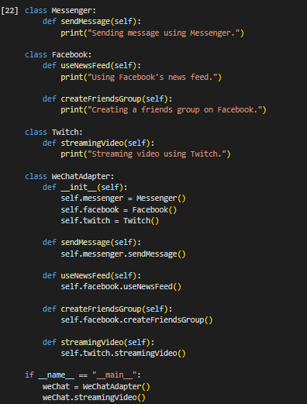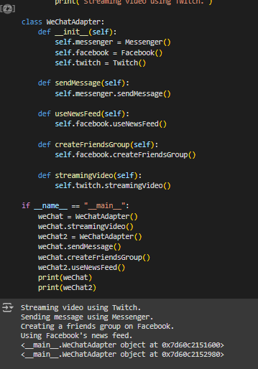

4.NO.Q.ANS
= In the example in the question it emphasized to the point of having 1 head chef to maintain consistency. Similarly in singleton design pattern there is always 1 instance of class to maintain stability and controlled settings. It makes sure that the update to 1 subject gets notified to its dependents automatically.

Code
class Singleton:
_instance = None

def __new__(cls):
if cls._instance is None:
cls._instance = super(Singleton, cls).__new__(cls)
print("1 instance created")
return cls._instance

def __init__(self):
self.info = "first instance"

singleton1 = Singleton()
print(singleton1.info)
singleton2 = Singleton()
print(singleton2.info)
print(singleton1 is singleton2)

